

LinkedIn Grad - Start your career

User Guide

## **Background**:

If you are a recent college graduate and anxious about your first job opportunity, you could try the mobile application *“LinkedIn Grad - Start your career”.*

This app could provide you several positive aspects involved creating a resume, reviewing your resume, accessing online courses, and job recommendations.

Don’t hesitate. Build your network, start your journey and make your dream come true.

## **Details**:

Users can download the app from Google Play Store for android OS and App Store for iOS easily and conveniently.

**Primary Features**

1. **Resume**

* CV’s system for users to upgrade their resume with the suggestion from AI.
* This is a crucial feature to build the fundamental background for users and attract the recruiters.
* Increase the acceptance rate of the 1st round (CV)

1. **Online Course**

* Training courses provide a lot of information for freshers to enhance their professional skills (marketing, computer science,...) and their soft skills (interview, presentation, negotiation, …)
* This is a supportive foundation that helps college graduates be outstanding in the next stages.

1. **Job Recommendation**

* Based on the professional and soft skills as well as the created resume, there are several suggestions about the suitable jobs for students.
* This is a vital step in the process of applying for a job, which could have positive impacts on the result of acceptance rate.
* Feature allows freshers to access the potential career of their aspects and directs them to follow.

**How to register and login**

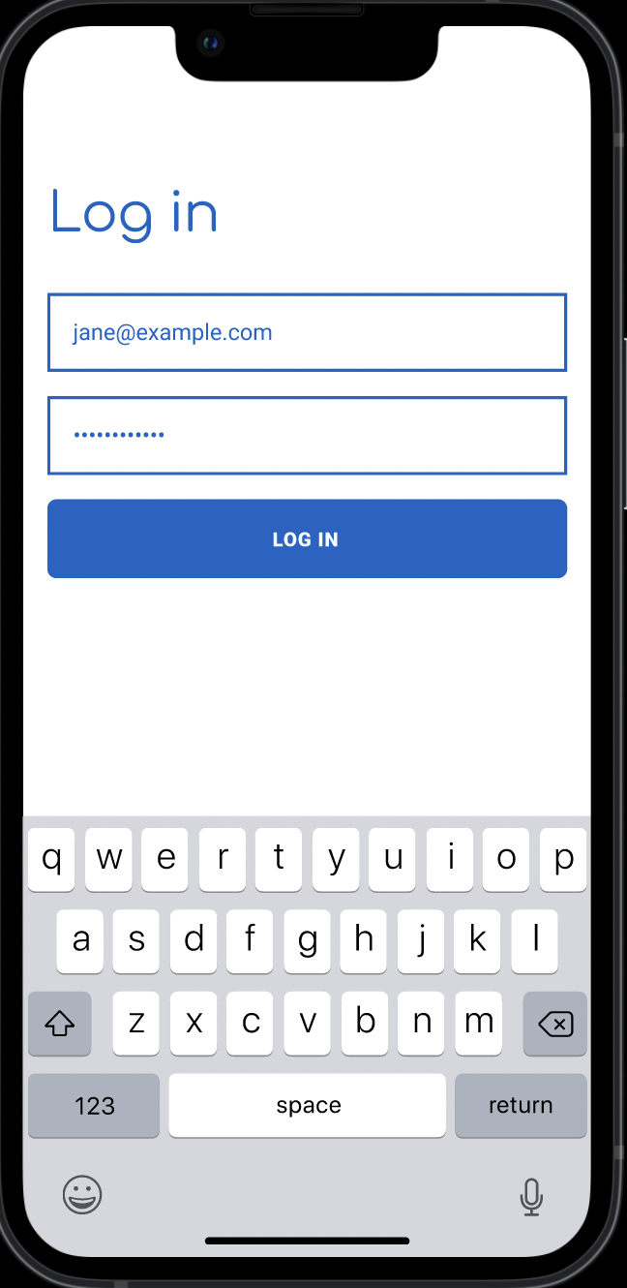

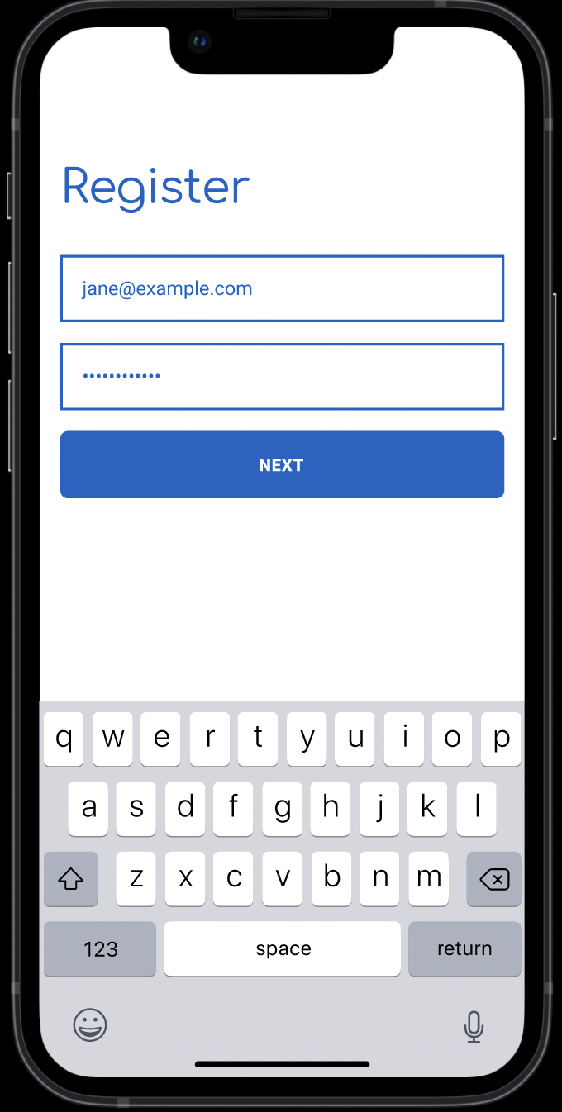

**How to create and review Resume**

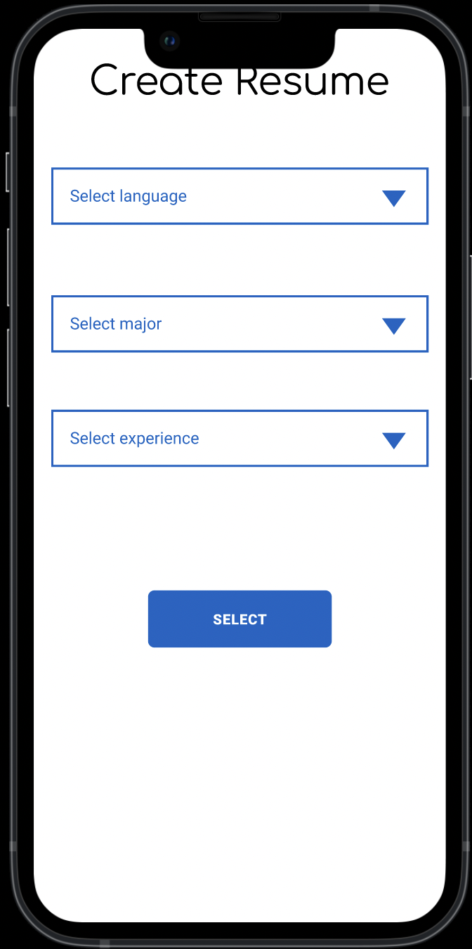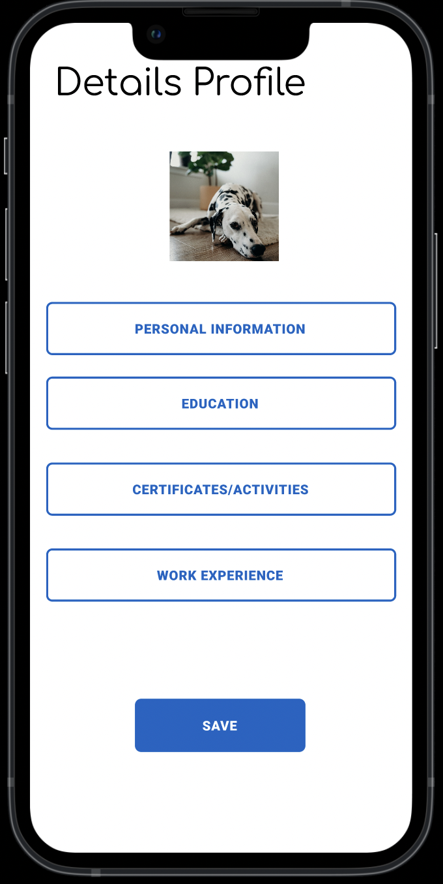

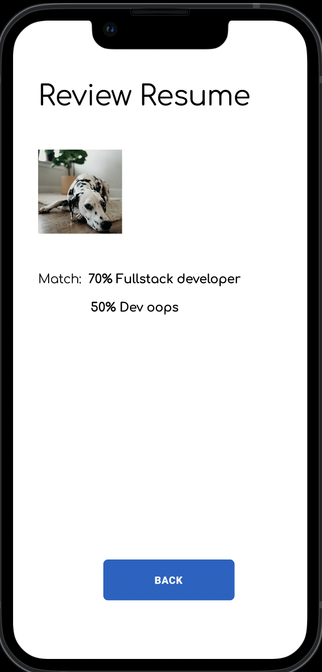

**How to apply a job from recommendation**